0000.doc
A small article in this magazine inspired swimwear supplier Philip
Crawford to offer his support to a worthy swim teaching project in Sri Lanka. He explains the background to the project and Mailsports’ donation of swimwear and teaching equipment

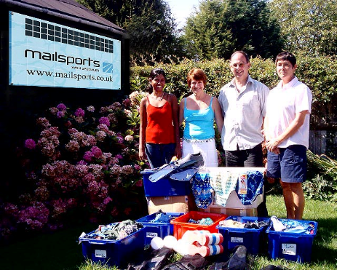
Above l-r: Inki Abeyratna, Mr and Mrs
Phillip Crawford and Christina Fonfe
The secluded pool in a coconut plantation with the donated swimwear and kit
Most readers will have seen our advertisements. Mailsports is an independent mail order and online swimwear company offering a range to suit the requirements of leisure and competitive swimmers alike. We were very pleased to welcome two very special guests to our showroom recently. Christina Fonfe, founder of the Aid Sri Lanka Foundation Women’s Swim Project, and her Sri Lankan scholarship student, Inki Abeyratna, visited us in Egham, Surrey, to receive a donation of swimwear and training aids to equip them for their return to Sri Lanka, where they will begin the next phase of their valuable work.
My wife, Lesley, and I read about Christina’s project in Swimming magazine earlier this year. It aims to provide Sri Lankan women with the chance to learn to swim, an opportunity that has never been available to them before. However, in the aftermath of the terrible tsunami disaster, which wracked the country at the end of 2004, this became a stated national need.
In the wake of the tsunami, Christina, from Marlow, Buckinghamshire, was shocked by an Oxfam report which stated that four times more women than men died in the disaster, reaching 80% of the casualties in certain regions. These alarming figures are mainly due to cultural factors of female decorum and a lack of both facilities and female swimming teachers, all of which serve to discourage teenage girls and adult women from swimming in public. In fact, most women in southern Sri Lanka won’t even paddle in the sea and certainly would not be seen in a tourist pool in the state of undress required for swimming. As a consequence, sadly, many women had no idea what to do when the water came. Countless numbers floundered an drowned. We are delighted that Mailsports’ donations have gone some way to towards helping to overcome these cultural barriers and get Sri Lanka’s women in the swim.
Christina said: “We are all quite bowled over by this generous donation and re-energised by sky high morale to get out there and get on with the job. These donations make a big difference to the project. Sri Lankan women would not normally wear a swimsuit in public and therefore most have
never learned to swim. When teaching modest and shy people to swim, it is essential to be able to offer them properly fitting modern swimwear.”
Christina made her first trip to Sri Lanka in February 2005, where she began work with the Aid Sri Lanka Foundation. Based in the southern coastal town of Weligama, she started to help Sri Lankan women conquer their lifelong fear of water. The project is proving tremendously successful. More than 30 children and several teenagers, all of whom were absolute beginners, received certificates for their progress in the water after only a few weeks. Now the second group of women is being recruited for lessons.
A secluded pool on a coconut plantation has been found and renovated for lessons, allowing the women the privacy they need to focus on learning – another vital step toward overcoming cultural barriers. Christina’s first all-female group comprised women teachers form the local school, where 200 of the 700 pupils were affected by the tsunami. Her object was to teach these women to swim so that they could pass on their skills to their own students, laying the foundations for making the project self-sustaining in years to come. Within this first group was Inki, Christina’s interpreter and her most promising student. Christina funded Inki’s visit to the UK, where she successfully completed her ASA Level 1 teaching qualification at the end of August. Not bad for a young lady who couldn’t swim a stroke in March! She will now return to Sri Lanka, where she will begin to teach swimming, in between undertaking her university studies.
The project is currently on the lookout for qualified female lifesaving and swimming instructors and tutors, plus qualified swimming teachers, who would be prepared to go to Sri Lanka as volunteers for a few weeks at a time to assist with the project.
Anyone interested should contact Christina or her husband Mike by e-mail at either mand.fonfe@macunlimited or michael.fonfe@onetel.net . The Aid Sri Lanka Foundation is in need of funds to sustain this worthy survival and self-sufficiency operation for women. For more information on the project or to make a donation to the Women’s Swimming Project, visit the website at http://www.aidsrilanka.org



